# AMP Installation

**APACHE:**

****<https://www.apachelounge.com/download/>  
Extract the fie land copy it to c:\apache  
Require: MS Visual C++ Redistributable; Add C:\Apache\bin to system path;  
Edit the file "C:\apache\conf\httpd.conf".  
Change all references from Apache24 to apache.  
***ServerName*** *localhost:80*c:\apache\bin>dir *.exe   
*httpd* will start the service:   
"C:\apache\htdocs\index.html" is the default document root.

**Run Apache as a Windows service:** c:\apache\bin>httpd.exe /?

**httpd -k install**  : install an Apache service

$ httpd -t 🡺 Syntax OK

OR: net start apache2.4

Check: cmd => services.msc; To uninstall apache: stop the service; httpd -k unistall.

**PHP:**

Extract it to c:\php. Look for **php7apache2_4.dll** file. This fiel is what apache service will look for in C:\apache\conf\httpd.conf:

*LoadModule php7_module "C:/php/php7apache2_4.dll"  
AddHandler application/x-httpd-php .php  
PHPIniDir "c:/php"*

Rename php.ini-development top php.ini (in c:\php directory)

Php.ini:

*display_errors = On (very important for development)*

Create in c:\apache\htdocs\phpinfo.php:

<?php

 phpinfo();

?>

Restart apache. Goto <http://localhost/phpinfo.php>

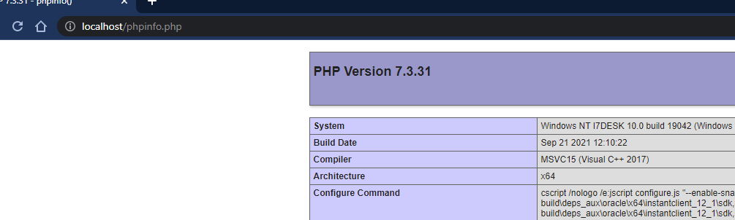

**MySQL**

[**https://downloads.mysql.com/archives/installer/**](https://downloads.mysql.com/archives/installer/)

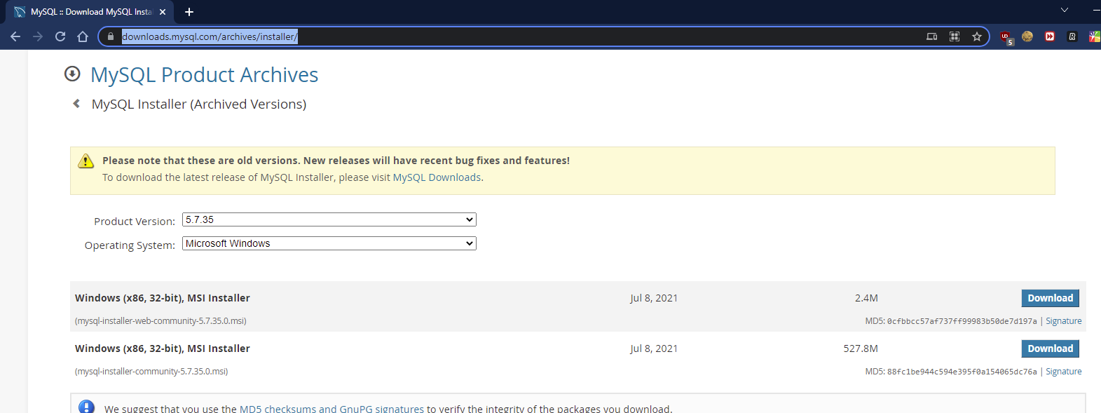

**Custom install (just the server and mysql workbench):**

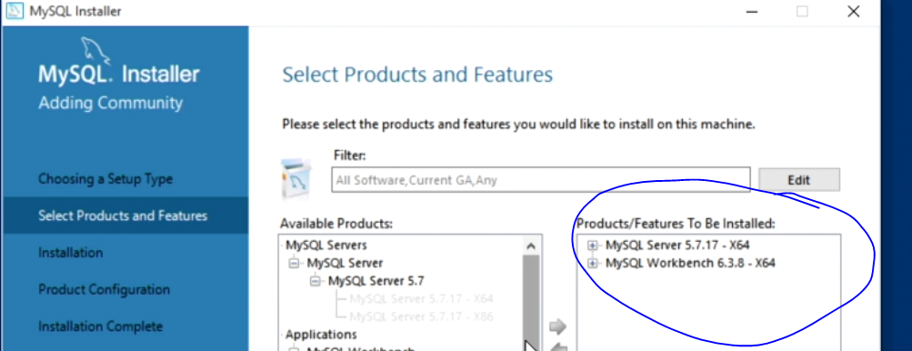

**Add mysql to path:**

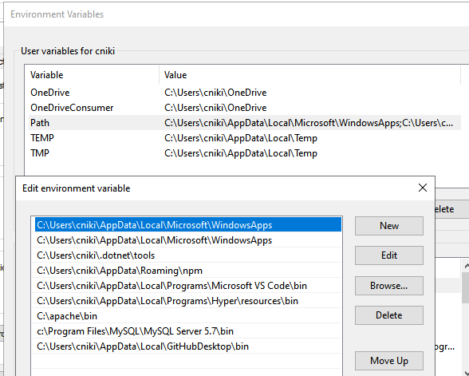

**Test connection:**

*# mysql -u root -p 🡺 root  
show databases;  
use sys;  
show tables;*